Rm -r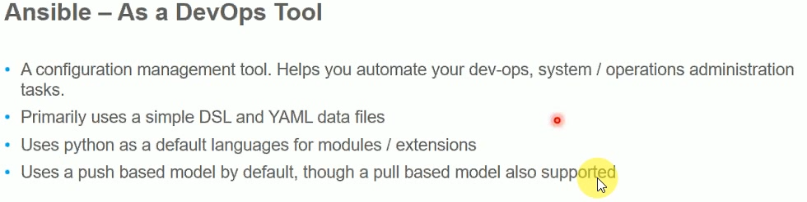

* Whenever we restart AWS instance. Our public ip address gets changed

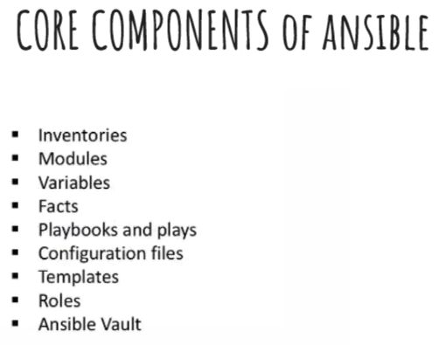

**Inventories:**

* Inventories is nothing but the list of all the nodes which our control server has to connect
* The list can be a static or dynamic list
* We write the list of nodes in inventory

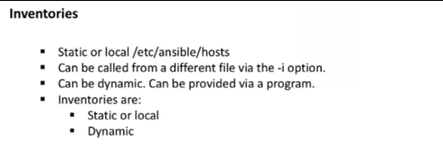

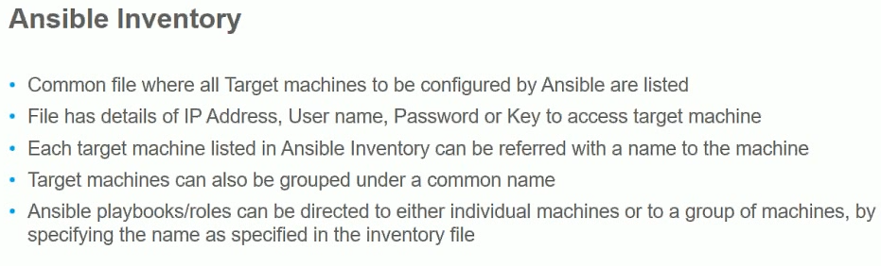

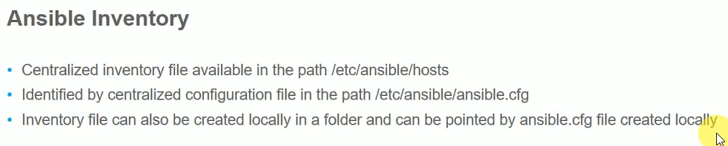

**Modules:**

* Modules are basically do the things for us
* Example, if we wat to install something on node using ansible, we need to find the right module to do that activity
* It is core in our day to day work
* For playbooks, we use modules instead of Linux commands
* Module is idempotent. There are some cases we do not guarantee idempotent
* To do any work in ansible, we need to know which module we need to use

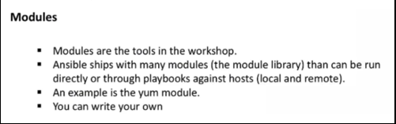

**Variables:**

* Some portions which may dynamic, repeat. Which we may want to pass to is called the variable
* example, if we want to copy a file to c drive. We can do it and another user wants to copy to d drive. He can do it. So, we can change the value whatever we want is called variable

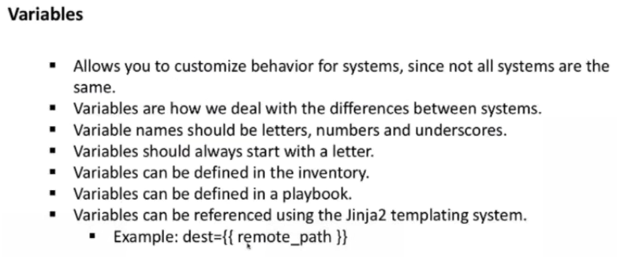

**Ansible facts:**

* Whenever we push something from server, it tries to gather some information form node like free space, what is the memory required, hostname etc. The collection of these details called ansible facts

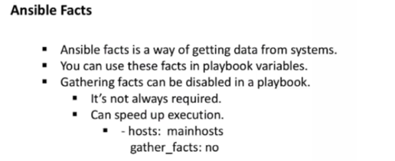

**Plays and playbooks:**

* Playbook is something like manual we write. So that we can execute that
* Playbook consists of different plays and plays consists of modules
* Play is an individual activity and every individual activity uses module

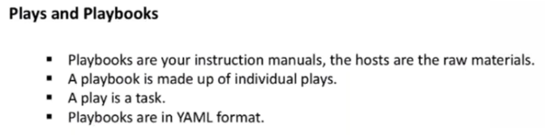

**Configuration files:**

* If we want ansible to work differently like the place it stores the inventory, the place it locks the info etc.
* We can change in configuration files
* The purpose of this is to change the default things in ansible

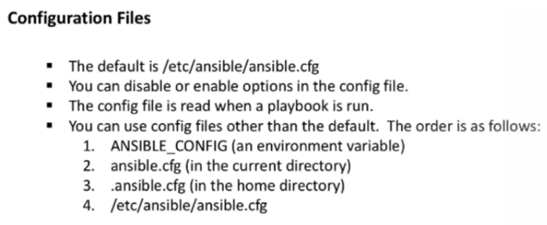

**Templates:**

* Template is something where we can change the file or name. it is combination of dynamic and static
* If it is whole static. Then no need of using templates

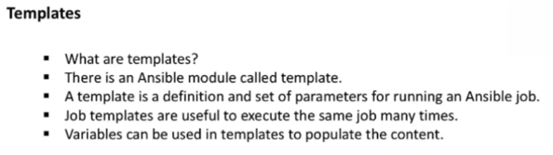

**Roles:**

* At the end, we use roles not playbooks. Because roles give better reusability
* In roles, we use handlers

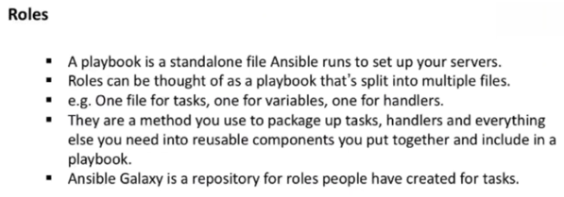

**Handlers:**

* Whenever we change apache configuration file, we need restart apache. We can use handler to restart whenever file modified. Such type of tasks is called handler

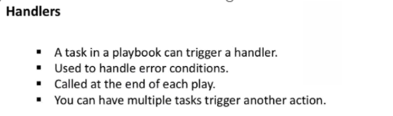

**Ansible vault:**

* If we have passwords to handle. We need to use vault

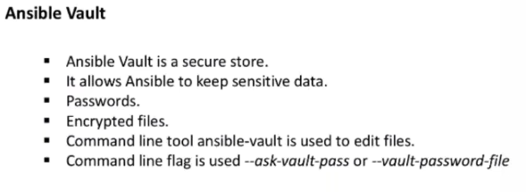

* Ansible tower is not the core concept of ansible. It is an enterprise way of handling ansible where it makes simple, UI and better reports etc.
* We can fine some basic ansible playbooks from below link
* **Github.com/asquarezone/ansiblezone**